# **BRAIN TUMOR DETECTION USING DEEP LEARNING**

SHUBH GUPTA YASH KUMAR MITTAL SHRUTI AGARWAL

Student, ABES EC Student, ABES EC Student, ABES EC

(Team Member) (Team Member) (Team Member)

SAIJAL SAWHNEY MRS. LATA YADAV

Student, ABES EC Assistant Professor, ABES EC

(Team Member) (Project Guide)

# **Abstract:**

Computational models that are powered by numerous deep learning methodologies at several processing levels that represent the data on different stages of abstraction. Deep learning technique is being used more and more frequently these days in practically every industry, but particularly in bio-informatics, image processing in medicine, and image analysis. Resulting fundamentally alteration and enhanced methods for successful recognition, prediction, and diagnosis in many health care domains, including pathology, lung cancer, brain tumor, abdominal and retina in deep learning. The review that was produced by condensing several contributions made to the field of science (such as deep learning)

**Keywords:** computational model, deep learning, image segmentation, brain tumor.

1. **Introduction:**

The development of medicinal technology aids professionals in providing patients in e-health care systems that are more effective. Electronic health care systems are useful in a variety of medical fields [2]. As they give the radiologist identification information for issues associated to the treatment, biomedical imaging based on tech-vision are becoming enhanced and more important. X-rays, MRIs, ultrasounds, and computed Tomography (CT) are a few of the medicinal imaging tools procedures having a significant impact on how patients are diagnosed and treated [1,5].

The beginning of the brain tumor is caused by creation of the aberrant cell clusters within or close to the brain [10]. The health of the patient is impacted by aberrant cells that interrupt the brain's processes. For clinical professionals and radiologists research on the analysis of brain imaging, therapy, and diagnosis using embraced medical imaging methodologies is a major area of concentration. Brain imaging analysis is regarded as essential as brain tumors are life-hazarding and are the cause of a significant death toll in wealthy countries [9,11].

The identification and treatment of brain tumors have utilized a broad variety of image-processing methodologies [1]. To remove the contaminated area in MRI images of brain tissues, segmentation is a critical step in image processing methodologies [2]. Regarding the examination, diagnosis, and treatment of the effectiveness of cancer treatments, segmenting the tumor territory is a crucial responsibility. Tumor segmentation uses a wide range of semi-loaded, automated segmentation procedures and methodologies [1,10].

Brain tumor segmentation studies use a variety of MRI characteristics, such as local histograms, and structural tensor eigenvalues, image textures [11]. Considering that they perform better in image analysis subfields such as object recognition, picture classification, and semantic segmentation, deep-learning-based approaches, and methodologies are becoming more and more prominent in brain tumor segmentation investigations [2]. Through the use of multiple-model MRIs [1]. A potent technique for picture recognition and prediction is the convolutional neural network (CNN).  CNN is primarily used to segment, classify, and forecast the survival time of brain tumors [2].

In order to find the most pertinent contribution, this review contains sizable research articles, the majority of which are recent, exhibiting a wide range of deep learning applications in brain tumor analysis. This review also includes articles from MICCAI workshops that discuss brain tumors [5]. Briefly stated the objectives of this review are to (a) demonstrate the advancement of the use of deep learning to brain tumors as a whole, (b) list unsolved problems in deep learning for assignments involving brain tumors, and (c) highlight the effective role that deep learning has had in analyzing brain tumors [1,11].

1. **Literature Survey:**

In this study, we used image processing to automate the diagnosing process for identifying brain tumors.

For MRIs of the brain, there are now numerous methods for brain tumor segmentation and identification [10]. The whole process of identifying a brain tumor has been covered, from the MRI image acquisition through the pre-processing processes to the accurate categorization of the tumor utilizing the two segmentation algorithms [1].

Pre-processing entails steps like the wavelet-based techniques that have been explored. Enhancements to the edges, noise reduction, and undesirable background removal enhance the detecting process and image quality, making quality enhancement and filtering crucial [1,12].

1. **Brain Tumor Classification:**

According to recent research articles, supervised machine learning and image classification tasks were successfully completed using deep learning techniques and approaches. Brain tumors come in a variety of forms, such as gliomas, meningiomas, and pituitary tumors [2]. Additional classifications for brain tumors are malignant and benign tumors. The most current studies on brain tumor analysis are explained in detail in the paragraphs that follow.

Due to size variations, position, contrast, and cellular structure of tumor tissue, classifying brain tumors is a difficult process. Glioma, meningioma, and pituitary forms of brain cancers are classified using cutting-edge deep learning approaches, in which axial, coronal, and sagittal planes are further subdivided. Axial slices are used to extract features using dense CNN segmentation methods, and recurrent neural networks are then used to classify the sequential characteristics of several frames [1]. Convolutional and fully linked networks are frequently utilized in brain tumor classification models [2].

Cytotechnologists are specialists who identify brain malignancies. The difference between astrocytes and low-grade astrocytomas is exceedingly difficult since astrocytes are glia-type nerve cells[2]. After identifying brain cells, segmentation is performed using binarization, watershed transform, and the Voronoi diagram. [1].

The investigation and depiction of deep characteristics is a crucial problem for the radiological MRI-based diagnosis and prediction of brain tumors [5]. In order to diagnose, treat, and predict outcomes for cancer patients, deep characteristics are retrieved from MRI scans. The radiometric qualities of the pictures have a definite relationship with significant biological traits and provide qualitative data that radiologists are accustomed to seeing [8]. The pre-trained CNNs approach uses feature extraction that is based on fine-tuning. A vast quantity of natural picture data is utilized to train fine-tuned CNNs [1], and they subsequently adopt feature representations that are employed for various brain tumors and include segmentation, classification [2].

# **Health care challenges and Scalability:**

It is a difficult undertaking to scale health care services, which involves the patient prioritizing process and patient analysis. As the population grows and more people need health care, the demand for such services eventually rises as well. The emergency state of patients determines the priority of healthcare interventions. Finding novel research contributions that can help create Building vital and challenging healthcare systems that are effective and efficient.[1]

The literature addressing the issue of the rising elderly patients count who want prompt and efficient telemedicine services is introduced in this part. In light of the aging population and catastrophic events, a rise in the number of patients is anticipated [1,11]. Although there are several problems with health care services, it is believed that the population's aging is the main problem [5,7].

Serious problems in the health care system are a result of significant demographic shifts [11]. By 2030, 13% of the world's population will be elderly, placing a tremendous strain on the healthcare system [1,8]. The manual treatment of major diseases is a challenging task for the global healthcare systems in terms of providing high-quality care [1,9].

1. **Data Visualization**.

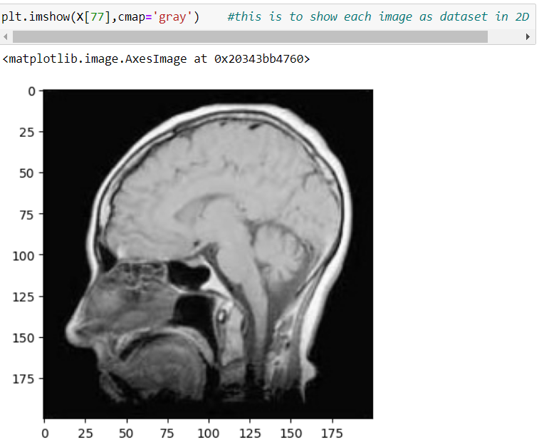

FIG 1. DATA VISUALISATION

In this, we can visualize our data set images through the command **plt.imshow().**

For EXAMPLE: Here we use **plt. imshow(X[77],cmap='gray')** which shows the image in77th position in the dataset.

# **Methodology:**

**Image acquisition:** This is the initial phase of our suggested project. The information presented here includes magnetic resonance imaging (MRIs) that were obtained in their original formats and (.ima, .dcm). The majority of MRI pictures are.dcm files (DICOM) Medical communications and digital imaging. File operations fopen() and fclose have been utilized. MRI image reading capabilities in Matlab. Here, the system is given input in the form of grayscale MRI scans [3,9].

**PRE-PROCESSING:** Several spatial filters, both linear and nonlinear, are used in the pre-processing step to reduce noise (Median filter). Some morphological methods removed additional artifacts, such as text. Conversion from RGB to grey and reshaping also take place here [2,6]. It has a median filter for noise cancellation. Noise can very seldom be detected by modern MRI images. It may have come as a result of a thermal effect. Preprocessing begins with converting the provided input MRI picture into a format that is appropriate for further processing [1,6]. The method dicom2image() is used to convert the DICOM image to a.jpeg file. The following are the main concerns with the preprocessing stage: -

1. Noise
2. Blur Low Contrast
3. The Bias
4. Partial Volume Effect.

**Image Smoothing:** It is the technique of simplifying the image while preserving important features. The goal is to eliminate noise or useless characteristics without introducing too much distortion in order to make subsequent analysis easier.

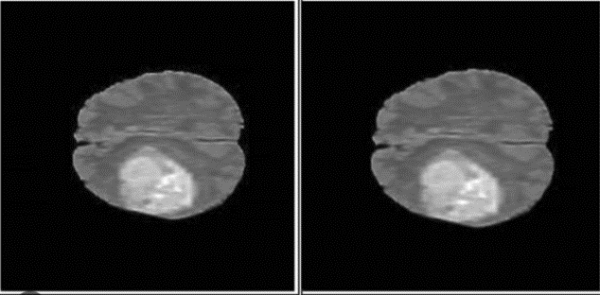

FIG 2: IMAGE SMOOTHENING

**Image Registration:** Image registration is the process of coordinating the spatial relationships between two or more images (aligning them). Image registration in the context of medical imaging enables the concurrent use of pictures captured using a range of imaging modalities.at varied times, a variety of patient postures. For instance, pictures are obtained both during and immediately following surgeries (preoperatively and intraoperatively, respectively) [4]. Preoperative pictures, which are obtained before surgery, have a higher resolution than real-time intraoperative images because of time restrictions. Additionally, it is challenging to link the patient's low-resolution intraoperative anatomy to the high-resolution pre-operative imaging due to the many deformations that occur during surgery [7,12].

**Image Segmentation:** For an image to be effectively analyzed, segmentation is the stage that is most crucial since it influences how accurately the remaining phases are performed. In addition, the boundary between certain lesions and the skin is uneven, whereas in other cases it is smooth. Many algorithms have been proposed to address this problem [2,4].

**Morphological order:** Morphological processing is used to eliminate undesirable parts following segmentation. It includes procedures for image opening, dilation, and erosion. By the end, it has been decided whether or not the MRI picture contains a tumor and if it is normal or aberrant [3]**.**

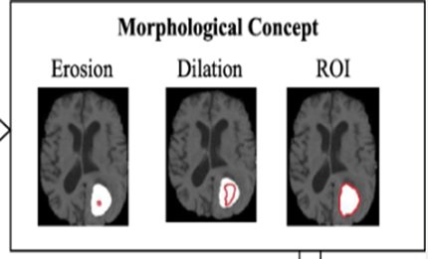

**FIG 3:** MORPHOLOGICALORDER

# **Design and implementation with accuracy graph:**

In this, we are describing the design and implementation of our project.

By using a flow chart, implementing the accuracy of the bar graph and

Result prediction images.

* 1. Flow chart and implementation

# 

FIG 4: FLOW CHART OF IMPLEMENTATION

* 1. BAR GRAPH OF ACCURACY OF RESULT

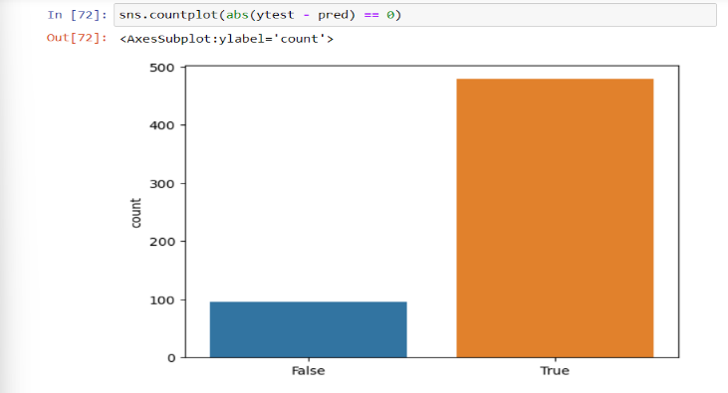

FIG 5: ACCURACY BAR GRAPH

In this, we get an accuracy graph in this out of 574 testing images we observe that nearly 480 images are predicted correctly.

* 1. RESULT PREDICTION

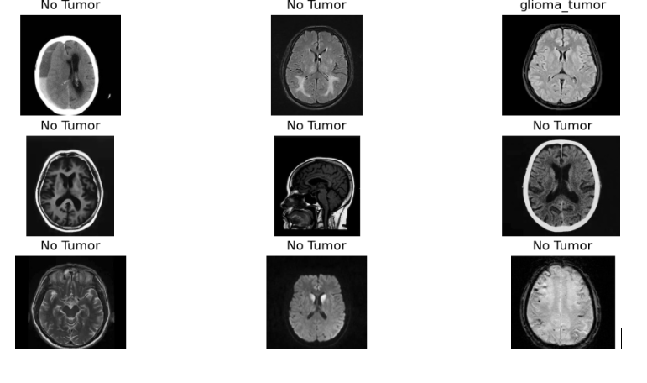

FIG 6: RESULT PREDICTION

In this figure, we observe our predicted result.

For example: In this, we figure we took our no-tumour testing dataset

And we try to predict from our model whether it gave the correct result or not. And we observe in this fig that 8 out of 9 images gave a result of no-tumour which is the correct output that shows that overall accuracy is very good. We can predict the same for other tumour images through this project.

# **Conclusion and Future Scope:**

In this study, we used image processing to automate the diagnosing process for identifying brain tumors.

For MRIs of the brain, there are now numerous methods for brain tumor segmentation and identification. The whole process of identifying a brain tumor has been covered, from the MRI image acquisition through the pre-processing processes to the accurate categorization of the tumor utilizing the two segmentation algorithms [2,6].

Pre-processing entails steps like the wavelet-based techniques that have been explored. Enhancement and filtering of the image's quality are essential since the quality of the image and the detection procedure are both improved by edge sharpening, enhancement, noise reduction, and unwanted background removal [4].

Finding the malignancy grade is a challenging task due to the complex structure of the lesion's region. This study offers a better method for first segmenting and categorizing brain tumors in order to increase patient survival rates. The inceptionv3 model is used in this study to recover the features, and Soft-max produces a score vector that is in case fed to a variational quantum classifier for the classification of brain tumors [7]. On two datasets that are accessible to the general public and one local dataset, the classification method's performance is assessed.

As of right now, CNN is the more accurate method for predicting the presence of brain tumours for the provided data set. Future brain tumour detection techniques may involve obtaining a three-dimensional picture of the brain affected by the tumour, which will allow us to determine the kind and stage of the tumour [1,2].

# **Reference:**

1. Muhammad Waqas Nadeem, Mohammed A. Al Ghamdi, Muzammil Hussain, Muhammad Adnan Khan et al. "Brain Tumor Analysis Empowered with Deep Learning: A Review, Taxonomy, and Future Challenges" , Brain Sciences, 2020
2. T Richie Emmanuel Armstrong, P.Manimegalai, A. Abinath, D. Pamela. "Brain tumor image segmentation using Deep learning", 2022 6th International Conference on Devices, Circuits and Systems (ICDCS), 2022
3. S. Karpakam, N. Senthilkumar, R. Kishorekumar, U. Ramani, P. Malini, S. Irfanbasha. "Investigation of Brain Tumor Recognition and Classification using Deep Learning in Medical Image Processing" , 2022 International Conference on Augmented Intelligence and Sustainable Systems (ICAISS), 2022
4. Mohsen, Heba, El-Sayed A. El-Dahshan, El-Sayed M. El-Horbaty, and Abdel-Badeeh M. Salem. "Classification using deep learning neural networks for brain tumors." Future Computing and Informatics Journal 3, no. 1 (2018): 68-71.
5. Amin, Javeria, Muhammad Sharif, Mudassar Raza, and Mussarat Yasmin. "Detection of brain tumor based on features fusion and machine learning." Journal of Ambient Intelligence and Humanized Computing (2018): 1-17.
6. Amin, Javaria, Muhammad Sharif, Mudassar Raza, Tanzila Saba, and Muhammad Almas Anjum. "Brain tumor detection using statistical and machine learning method." Computer methods and programs in biomedicine 177 (2019): 69-79.
7. Nazir, Maria, Sadia Shakil, and Khurram Khurshid. "Role of deep learning in brain tumor detection and classification (2015 to 2020): A review." Computerized Medical Imaging and Graphics 91 (2021): 101940.
8. Amin, Javaria, Muhammad Sharif, Anandakumar Haldorai, Mussarat Yasmin, and Ramesh Sundar Nayak. "Brain tumor detection and classification using machine learning: a comprehensive survey." Complex & Intelligent Systems (2021): 1-23.
9. Liu, Zhihua, Lei Tong, Long Chen, Zheng Jiang, Feixiang Zhou, Qianni Zhang, Xiangrong Zhang, Yaochu Jin, and Huiyu Zhou. "Deep learning-based brain tumor segmentation: a survey." Complex & Intelligent Systems (2022).
10. D. Jain, P. Singh, V. Rohatgi, R. Raj, A. Sharma and S. Bansal, "Pneumonia Detection using Customized CNN," 2022 4th International Conference on Advances in Computing, Communication Control and Networking (ICAC3N), Greater Noida, India, 2022, pp. 261-264, doi: 10.1109/ICAC3N56670.2022.10074473.
11. H. Malhotra, K. Arora, K. Gogia, P. Raj, D. Jain and P. Singh, "Machine Learning for Diabetes, Heart Disease, Pneumonia, and Covid-19 Diagnostics," 2022 4th International Conference on Advances in Computing, Communication Control and Networking (ICAC3N), Greater Noida, India, 2022, pp. 265-270, doi: 10.1109/ICAC3N56670.2022.10074463.
12. D. Jain, P. Singh, A. K. Pandey, M. Singh, H. Singh and A. Singh, "Lung Cancer Detection Using Convolutional Neural Network," 2022 3rd International Conference on Issues and Challenges in Intelligent Computing Techniques (ICICT), Ghaziabad, India, 2022, pp. 1-4, doi: 10.1109/ICICT55121.2022.10064513.